Serving These Communities and More
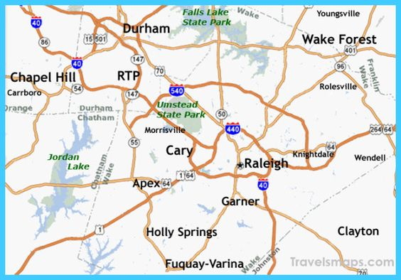

Apex Burlington Carrboro
Cary Chapel Hill Clayton
Creedmoor Durham Fuquay-Varina
Garner Hillsborough Holly Springs
Knightdale Morrisville New Hill
Pittsboro Rolesville Smithfield
Wake Forest Wendell Willow Springs
Whitsett Youngsville Zebulon

